**TECHNOETIC ARTS**

PROJECT PROPOSAL PAGE

**COURSE:** TOOLS, SOFTWARE, AND SYSTEMS IV

**YEAR:** 2

**LECTURER:** Minka

**ASSIGNMENT TITLE:** MODULE 3

**STUDENT NAME(s):** Hu Jiayue/ Jaya

**DATE:**2018/ 3/ 19

**PROJECT TITLE:** THE WEBSITE I WANT TO DO.

1. **DESCRIPTION:** 
   1. Simple, clear, outstanding personal style + a little animation element.

2. Background the elements that were liked at the time.

3. The menu in the upper right corner of a small button, open the vertical display.

Menu: front page, style (at that time, like elements), my work, music sharing, film sharing, fashion sharing, casual.

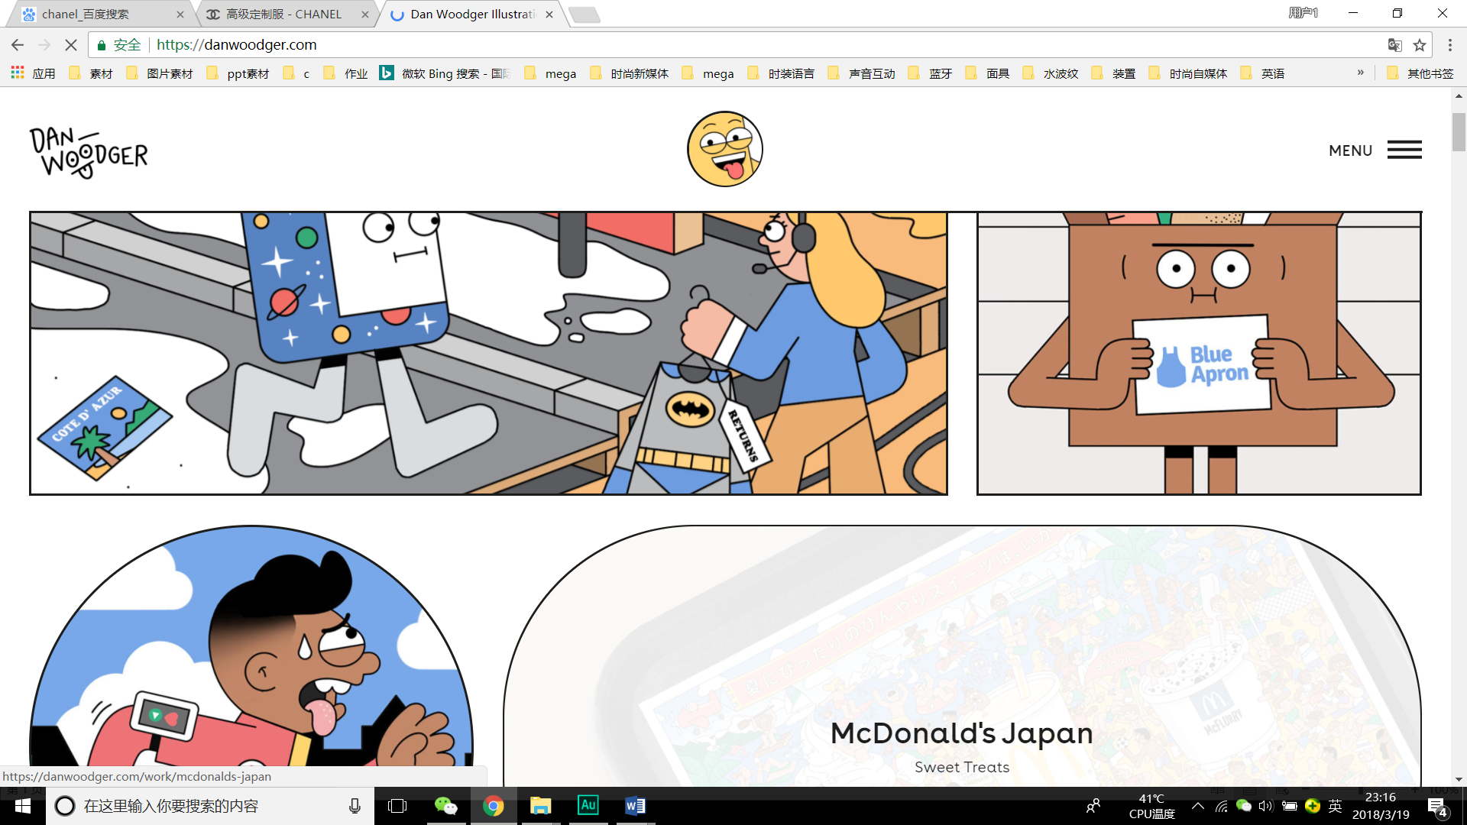

3. 3D button click to enter the content of the work.

4. Homepage: latest content.

5. End of the page: personal information: WeChat, weibo, ins.

6. The tone of the page will change as I like.

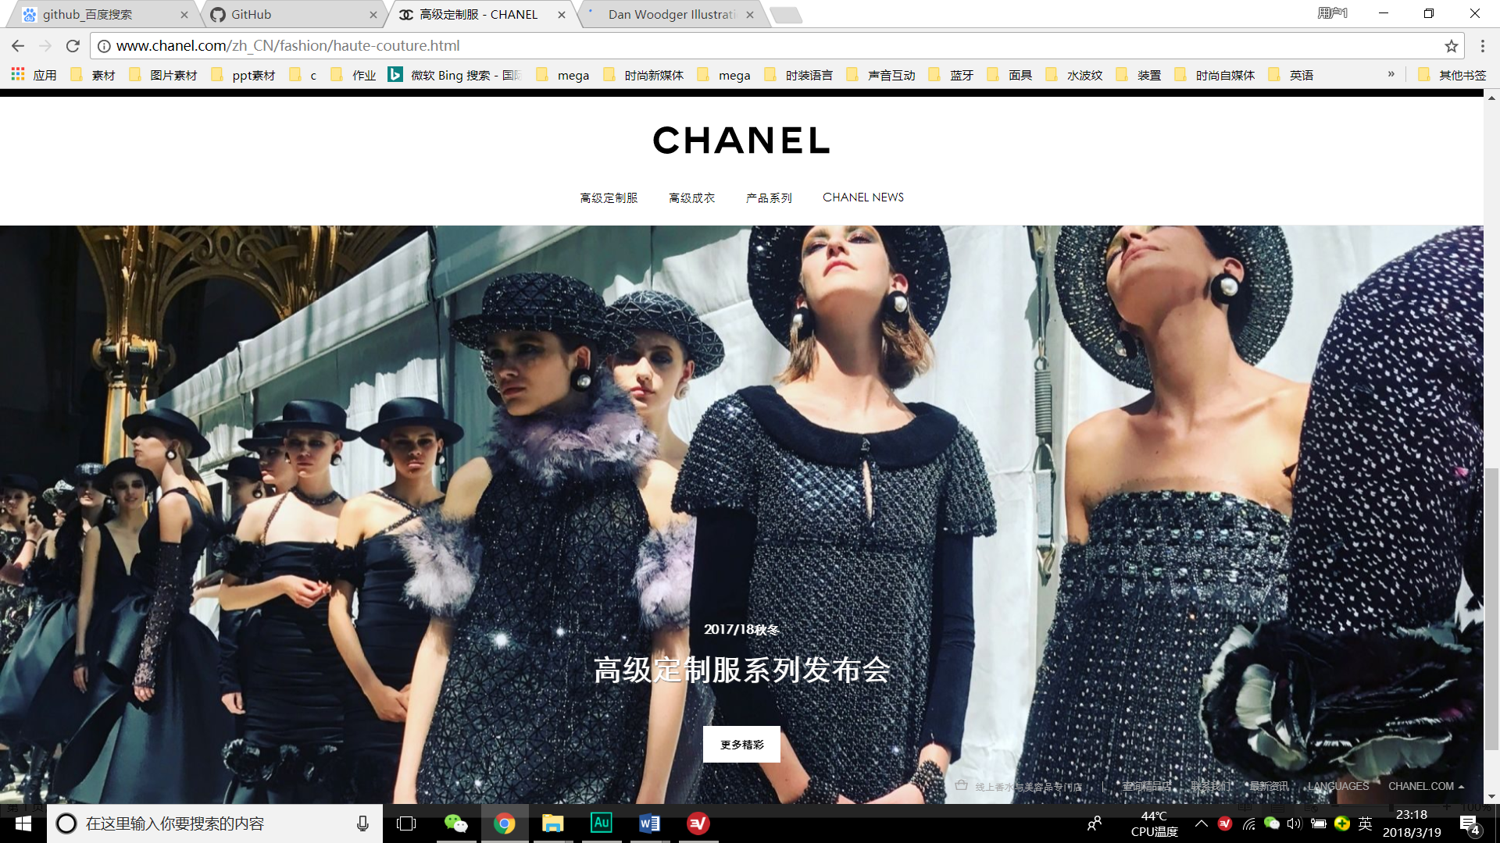

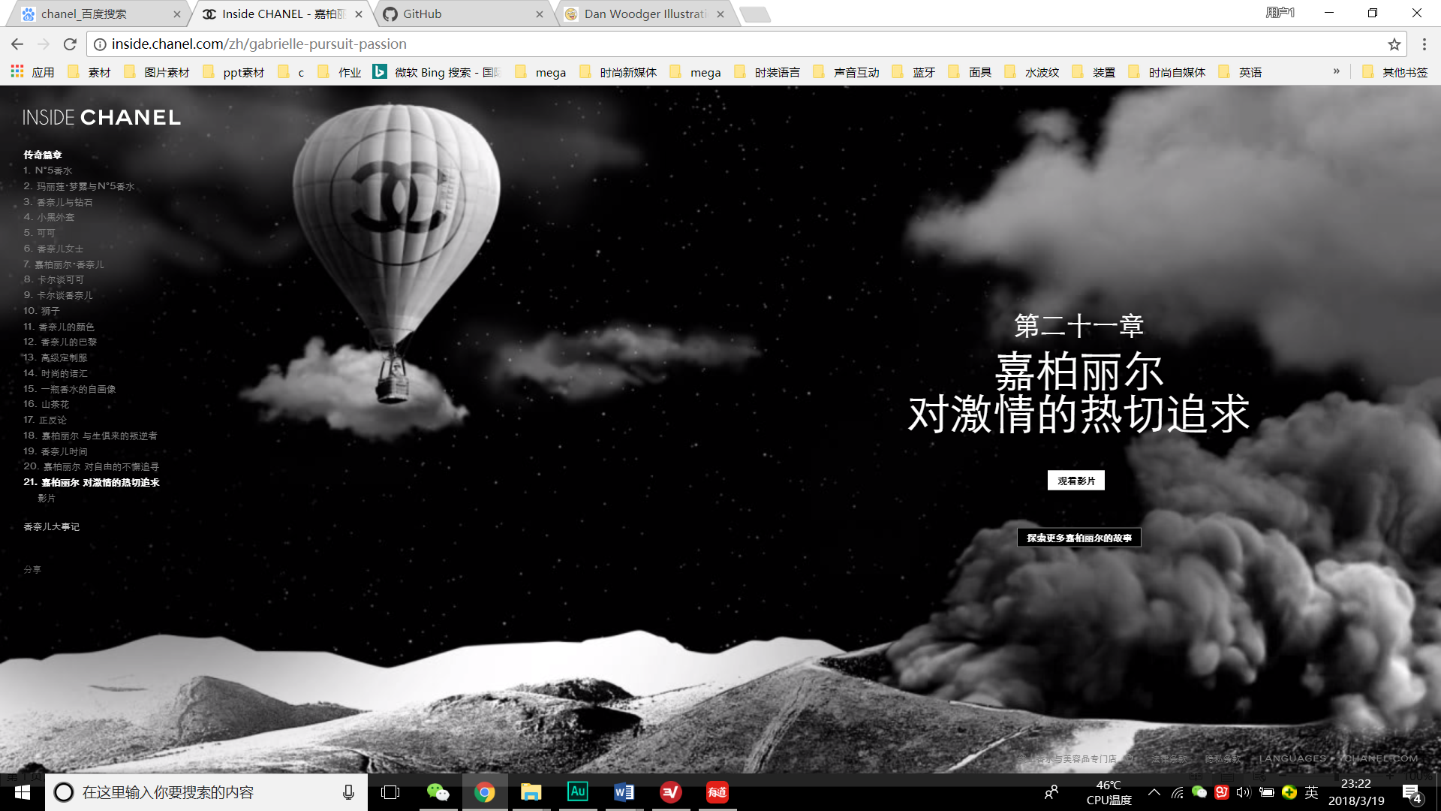

7. My logo will appear in the buffer.

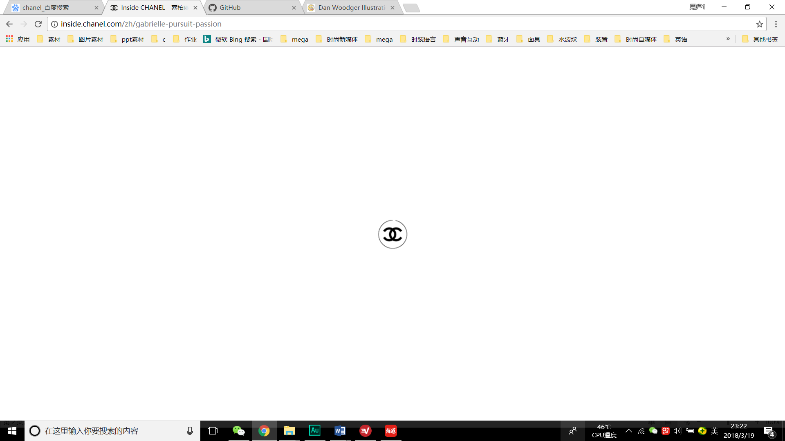

8. My main works pictures will appear in a full background, other details in this way：

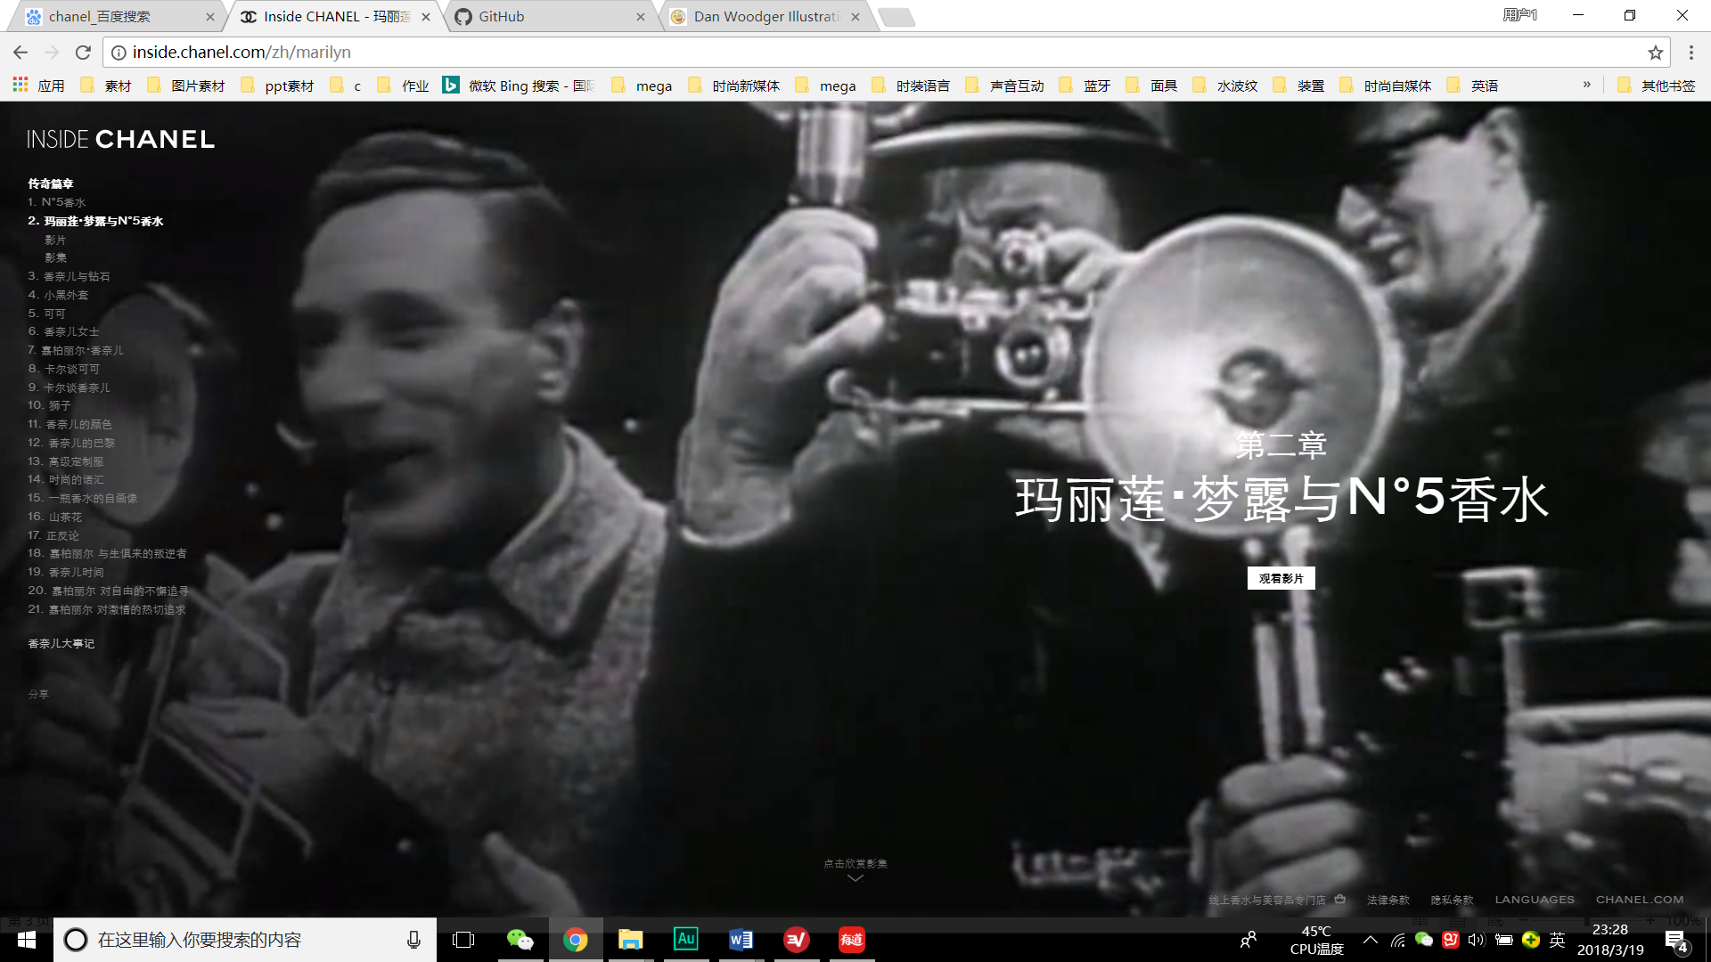

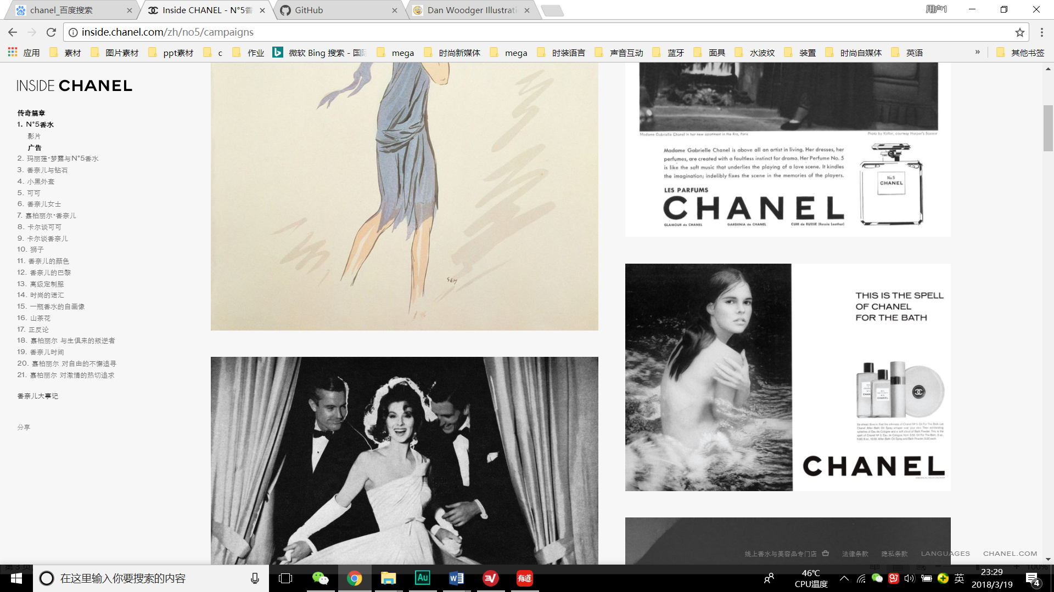

The mouse button will appear on top when you put your mouse on the picture. When you touch it, and you will see the detail.

